Anton Savelyev

James Brisky

Carlos Moreno

CSCI 256

Project Report

Our project consisted of implementing a data sample importance prioritization algorithm in wireless body sensor networks. It has been well established that the quality of data for BSNs is affected by the limited bandwidth, the inherent data loss in wireless networks, and the size of the network. Therefore, in order to maintain a quality of service for WBANs, it is necessary that samples are prioritized in some fashion. This is because, for any data lost, it is easy to recover the sample values using linear interpolation. However, the accuracy of such an approach heavily depends on what data is actually received on the receiver side. Based on [1], we classify samples into 5 different priority levels. For this project, we have made the simplifying assumption that priority levels 0 and 1 are considered priority packets, while samples of priority levels 2, 3, and 4 are interpreted as non-priority packets.

We implemented this prioritization algorithm using two TelosB motes as our sensors. These sensors are based on TinyOS and nesC. As our major components, we have one sensor acting as the sender and the second sensor as the receiver. The sender is wirelessly transmitting the packets to the receiver. The receiver is attached to the laptop in order to properly display the received samples. In general, our project followed this flow:

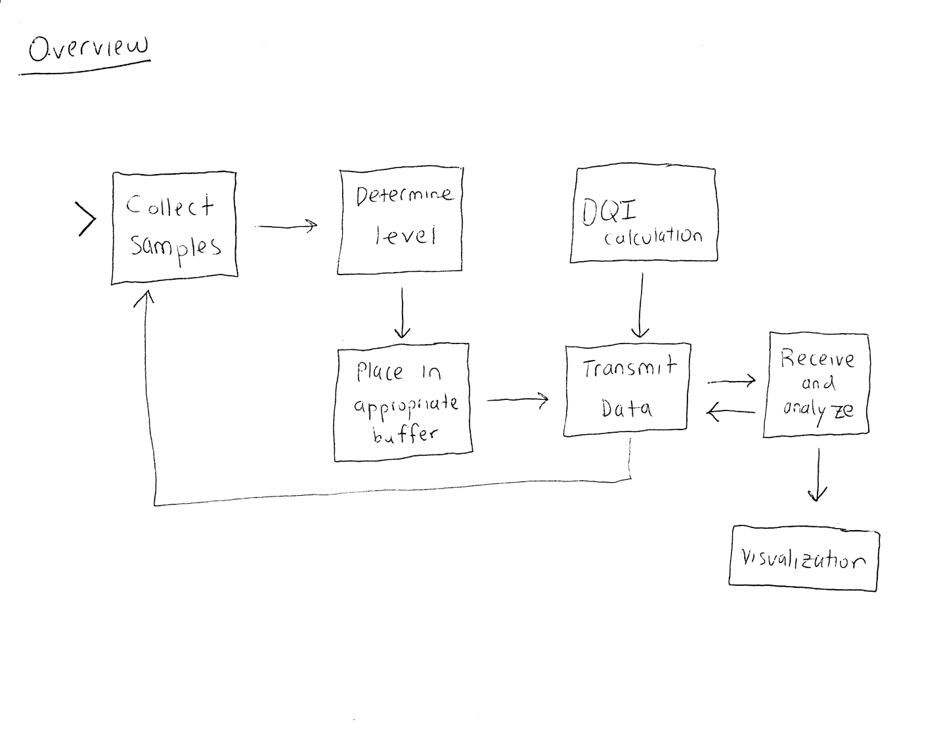

However, rather than actually collect samples in real-time, we are using fixed jogging data. This makes the data analysis much easier to do.

For the data analysis, we explored how well the estimated values matched up against the actual values. To do this, we use the DQI calculation, which is defined as ${DQI}_{1}=\frac{\left|estimate−actual\right|}{actual}$. This value is then subtracted from 100 to get a percentage. These percentages are kept as a running total. This total is then divided by the number of samples, which results in the total average DQI for all samples. We used this analysis on six different scenarios.

We also noted that using this DQI calculation has issues: because the actual value is much larger than the difference, it results in small DQI values, regardless of the differences. Therefore, to make a more appropriate calculation, we used two additional DQI methods: global range and local range; ${DQI}_{2}=\frac{\left|estimate−actual\right|}{globalmax−globalmin}$ and ${DQI}_{3}=\frac{\left|estimate−actual\right|}{localmax−localmin}$.

|  |  |  |  |  |
| --- | --- | --- | --- | --- |
| Scenario # | Description | Total average DQI using actual value method | Total average DQI using global range method | Total average DQI using local range method |
| 1 | Priority levels 0 and 1 are priority packets, priority levels 2 through 4 are non-priority packets, 50% packet loss rate | 93.9019% | 93.7465% | 78.0325% |
| 2 | Priority level 0 is priority packets, non-priority packets are not sent, 0% packet loss rate | 95.9648% | 95.4849% | 88.8336% |
| 3 | Priority levels 0 and 1 are priority packets, non-priority packets are not sent, 0% packet loss rate | 98.2189% | 98.1809% | 95.7782% |
| 4 | Priority levels 0 through 2 are priority packets, non-priority packets are not sent, 0% packet loss rate | 97.9862% | 98.0348% | 93.9129% |
| 5 | Priority packets do not exist, all priority levels are non-priority packets, 50% packet loss rate | 91.9776% | 91.5581% | 67.5838% |
| 6 | Priority packets do not exist, all priority levels are non-priority packets, 0% packet loss rate | 100% | 100% | 100% |

Two cases that are interesting to compare are cases 1 and 5. Both cases use a loss rate of 50%. Case 5 treats no samples as priority and acts as a control, while case 1 treats L0 and L1 packets as priority. As can be seen in the table, case 1 has a higher DQI than case 5 using all three different DQI tests, showing that prioritizing samples does increase DQI compared to not prioritizing them.

The other interesting comparison uses cases 2, 3, and 4. In all three cases, priority samples are sent without any intentional loss, and non-priority samples are not sent at all. Case 2 treats L0 samples as priority, case 3 treats L0 and L1 samples as priority, and case 4 treats L0-L2 samples as priority. As expected, the results improve moving from case 2 to 3. Adding the L1 samples improves DQI. Unexpectedly, case 4 performs slightly worse than case 3. Adding the L2 samples caused DQI to drop. We believe the reason for this is random packet loss between the sensors. In our testing we hard coded a loss rate into the sender and receiver, but some small amount of packets were lost naturally as well. Our early results are promising, but we need to run more tests to rule out these kind of anomalies.

Reference

[1] M. Li, Y. Cao, and B. Prabhakaran, "Multi-level Sample Importance Ranking based Progressive Transmission Strategy for Time Series Body Sensor Data," *World of Wireless, Mobile and Multimedia Networks (WoWMoM), 2015 IEEE 16th International Symposium on a*, Boston, MA, 2015, pp. 1-3.